Experiment No.4

Title:-Greedy Method to solve problems of optimal merge pattern.
Problem:- Huffman Coding
Building an optimal prefix code for data compression.
The process of repeatedly merging the two smallest frequency nodes is a direct application of the optimal merge pattern.
Programm:-
#include <stdio.h>
#include <stdlib.h>
#include <string.h>
#define MAX_TREE_HT 100
// A Huffman tree node
typedef struct MinHeapNode {
char data; // character
unsigned freq; // frequency of character
struct MinHeapNode *left, *right;
} MinHeapNode;
// Min-Heap: collection of min-heap (or Huffman tree) nodes
typedef struct MinHeap {
unsigned size;
unsigned capacity;
MinHeapNode** array;
} MinHeap;
// Create a new node
MinHeapNode* newNode(char data, unsigned freq) {
MinHeapNode* temp = (MinHeapNode*) malloc(sizeof(MinHeapNode));
temp->left = temp->right = NULL;
temp->data = data;
temp->freq = freq;
return temp;
}
// Create a min-heap of given capacity
MinHeap* createMinHeap(unsigned capacity) {
MinHeap* minHeap = (MinHeap*) malloc(sizeof(MinHeap));
minHeap->size = 0;
minHeap->capacity = capacity;
minHeap->array = (MinHeapNode**) malloc(minHeap->capacity * sizeof(MinHeapNode*));
return minHeap;
}
// Swap two nodes
void swapMinHeapNode(MinHeapNode** a, MinHeapNode** b) {
MinHeapNode* t = *a;
*a = *b;
*b = t;
}
// Heapify at given index
void minHeapify(MinHeap* minHeap, int idx) {
int smallest = idx;
int left = 2*idx + 1;
int right = 2*idx + 2;

if (left < minHeap->size && minHeap->array[left]->freq < minHeap->array[smallest]->freq)
smallest = left;
if (right < minHeap->size && minHeap->array[right]->freq < minHeap->array[smallest]->freq)
smallest = right;
if (smallest != idx) {
swapMinHeapNode(&minHeap->array[smallest], &minHeap->array[idx]);
minHeapify(minHeap, smallest);
}
}
// Check if size is 1
int isSizeOne(MinHeap* minHeap) {
return (minHeap->size == 1);
}
// Extract minimum value node
MinHeapNode* extractMin(MinHeap* minHeap) {
MinHeapNode* temp = minHeap->array[0];
minHeap->array[0] = minHeap->array[minHeap->size - 1];
minHeap->size--;
minHeapify(minHeap, 0);
return temp;
}
// Insert a new node
void insertMinHeap(MinHeap* minHeap, MinHeapNode* minHeapNode) {
minHeap->size++;
int i = minHeap->size - 1;
while (i && minHeapNode->freq < minHeap->array[(i - 1)/2]->freq) {
minHeap->array[i] = minHeap->array[(i - 1)/2];
i = (i - 1)/2;
}
minHeap->array[i] = minHeapNode;
}
// Build min-heap
void buildMinHeap(MinHeap* minHeap) {
int n = minHeap->size - 1;
for (int i = (n-1)/2; i >=0; i--)
minHeapify(minHeap, i);
}
// Create and build min-heap from characters and frequencies
MinHeap* createAndBuildMinHeap(char data[], int freq[], int size) {
MinHeap* minHeap = createMinHeap(size);
for (int i=0; i<size; ++i)
minHeap->array[i] = newNode(data[i], freq[i]);
minHeap->size = size;
buildMinHeap(minHeap);
return minHeap;
}
// Build Huffman Tree
MinHeapNode* buildHuffmanTree(char data[], int freq[], int size) {
MinHeapNode *left, *right, *top;
MinHeap* minHeap = createAndBuildMinHeap(data, freq, size);
while (!isSizeOne(minHeap)) {
left = extractMin(minHeap);
right = extractMin(minHeap);
top = newNode('$', left->freq + right->freq);
top->left = left;
top->right = right;
insertMinHeap(minHeap, top);
}
return extractMin(minHeap);
}
// Print Huffman codes
void printCodes(MinHeapNode* root, int arr[], int top) {
if (root->left) {
arr[top] = 0;
printCodes(root->left, arr, top + 1);
}
if (root->right) {
arr[top] = 1;
printCodes(root->right, arr, top + 1);
}
if (!(root->left) && !(root->right)) {
printf("%c: ", root->data);
for (int i=0; i<top; i++)
printf("%d", arr[i]);
printf("\n");
}
}

// Huffman encoding function
void HuffmanCodes(char data[], int freq[], int size) {
MinHeapNode* root = buildHuffmanTree(data, freq, size);
int arr[MAX_TREE_HT], top = 0;
printf("Huffman Codes:\n");
printCodes(root, arr, top);
}
// Main function
int main() {
char arr[] = {'a', 'b', 'c', 'd', 'e', 'f'};
int freq[] = {5, 9, 12, 13, 16, 45};
int size = sizeof(arr)/sizeof(arr[0]);

HuffmanCodes(arr, freq, size);
return 0;
}
Output:- 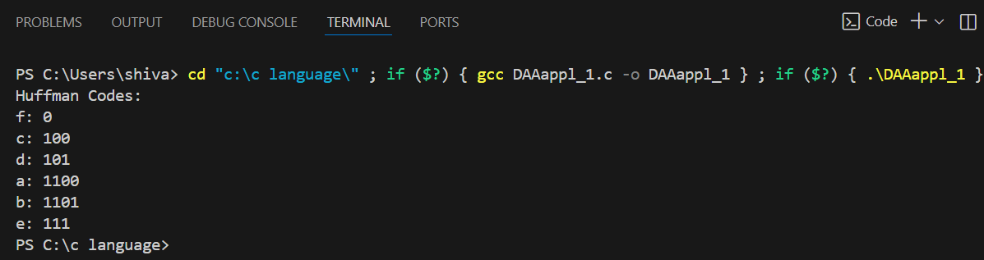

Real-World Applications of Optimal Merge Pattern (Greedy Method)
- File Compression
  - Combining multiple smaller files into a single archive efficiently (like ZIP or TAR).
  - Minimizes total read/write operations, speeding up compression.
- Database Query Optimization
  - Merging multiple sorted database query results (joins, indexes) efficiently.
  - Reduces the number of disk accesses and comparison operations.
- External Sorting
  - Sorting huge datasets that cannot fit into memory (external sort).
  - Merging smaller sorted runs on disk with minimal I/O operations.
- Huffman Coding
  - Building an optimal prefix code for data compression.
  - The process of repeatedly merging the two smallest frequency nodes is a direct application of the optimal merge pattern.
- Log File Aggregation
  - Merging multiple server log files into a single chronological file efficiently.
  - Reduces processing time when logs are very large.
- Document and Media File Management
  - Combining video clips, audio files, or documents into a single file while minimizing the total merge time.
- Big Data Processing
  - Merging sorted outputs of distributed computations in MapReduce or other distributed frameworks.
  - Greedy merging reduces network and disk overhead.

